Bootstrap Tasks - Proper Format

Task 1 — Setup a New Project
Description: Create a new HTML file, link Bootstrap via CDN, and use a container to confirm styling.
Code:
<!DOCTYPE html>
<html lang="en">
<head>
<meta charset="UTF-8">
<meta name="viewport" content="width=device-width, initial-scale=1.0">
<title>Bootstrap Page</title>
<!-- Bootstrap -->
<link href="https://cdn.jsdelivr.net/npm/bootstrap@5.3.8/dist/css/bootstrap.min.css" rel="stylesheet">
<style>
body {
background: linear-gradient(to right, #2c3e50, #4ca1af);
font-family: Arial, sans-serif;
}
.header-box {
border-radius: 10px;
box-shadow: 0 4px 10px rgba(0,0,0,0.3);
}
#btn {
display: block;
margin: 50px auto;
font-size: 18px;
padding: 10px 20px;
border-radius: 8px;
transition: 0.3s;
}
#btn:hover {
background-color: #0d6efd;
color: white;
transform: scale(1.1);
}
.info-text {
text-align: center;
color: white;
margin-top: 20px;
font-size: 18px;
}
</style>
</head>
<body>
<div class="container-fluid bg-dark p-5 w-100 text-white text-center header-box">
<h1>WELCOME TO BOOTSTRAP PAGE</h1>
<p>Styled with Bootstrap + Custom CSS</p>
</div>

<button id="btn" onclick="clickme()" class="btn btn-secondary mt-10">
Click Me
</button>
<p class="info-text">Click the button to see action</p>
<script>
function clickme(){
alert("Welcome to Bootstrap page ");
}
</script>
</body>
</html>
OUTPUT: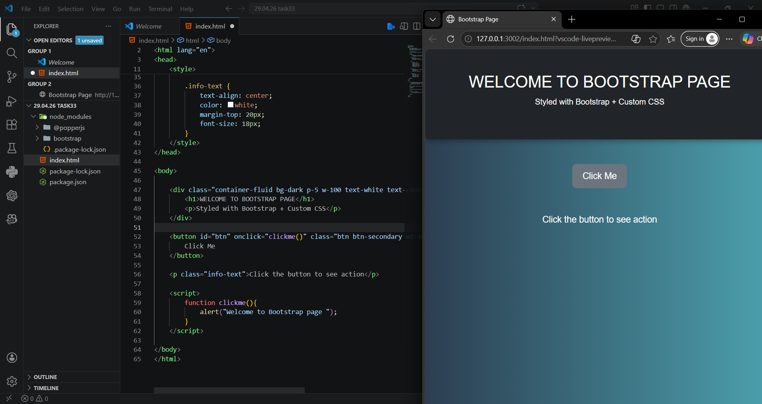

Task 2 — Typography & Spacing
Description: Use Bootstrap text utilities and spacing classes like padding and margin.
Code:
<!DOCTYPE html>
<html lang="en">
<head>
<meta charset="UTF-8">
<meta name="viewport" content="width=device-width, initial-scale=1.0">
<title>bootstrap Typography & Spacing</title>
<link href="https://cdn.jsdelivr.net/npm/bootstrap@5.3.8/dist/css/bootstrap.min.css" rel="stylesheet">
</head>
<body>
<div>
<h1 class="text-center text-light mb-4 mt-5 bg-primary p-5">Bootstrap Typography & Spacing</h1>
<div class="ontainer-fluid bg-dark p-5 w-100 text-white text-center header-box p-3">
<p> This is a paragraph using Bootstrap text </p>
</div>
<div class="p-4 mt-4 bg-warning text-dark">
<h3 class="text-center">Styled Section</h3>
<p class="text-center">
This section uses padding and margin utilities.
</p>
</div>
</div>
</body>
</html>
OUTPUT:
